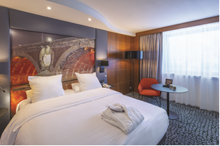

BOOKING FORM for ICCM 2024 Seminar (June 23rd to june 26th)

Please complete the booking form and return it to the Hotel
Price valid for the nights of 23, 24 and 25 only and depending on the availability

Last name: ________________________________ First name: _______________________________________________
Address: _________________________________________________________________________________________________
__________________________________________________________________________________________________________
E-mail: __________________________________________________________________________________________________
Phone: _______________________________________ Fax number: _______________________________________________

Please book: ____ single room (s) - ____ double room (s) - ____ twin room (s) for ____ night(s)
Arrival date : ___________________________ Departure date : ____________________________

Individual room, breakfast included : € 148
Supplement of €14 for a double/twin room : €162 per room and per night
City tax : € 2.53 per person and per night

I duly authorise you to charge from my credit card number, any cancellation fee as indicated on Cancellation policy.
Credit Card: Visa ( ) Eurocard ( ) MasterCard ( ) American Express ( ) Diners Card ( )

N° ______________ ___________

Cryptogram (the last 3 figures on the back of the card) ___________
Expiry date: ________________________ Owner of the Credit Card: _________________________________________
Made in _______________________ the _______________________ Signature __________________________________

Booking policy

* No booking will be registered without credit card information
* The entire stay will be debited at the time of your reservation.
* The Hotel will reconfirm the participant booking within 3 days.
* After the booking deadline above indicated, bookings will be registered according to availabilities and with the rate of the day

Cancellation policy

* For any cancellation made 10 days before the check in, there will be no cancellation fees
* For any cancellation made later than 10 days, the hotel will charge you the total amount of the reservation.
* In case of no show, the whole stay will be charged on your credit card

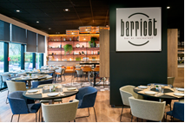

Mercure Toulouse Centre Compans ****
8 Esplanade Compans Caffarelli
31000 TOULOUSE

Tél. 05 61 11 09 09 – Fax. 05 61 23 14 12 – E-mail : H1585@accor.com

